**PIZZA SALES SQL QUERIES**

**1. Total Revenue :**

SELECT sum(total_price) AS Total_Revenue FROM sales;

**OUTPUT:**

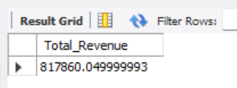

**2.Average Order Value :**

SELECT sum(total_price) / count( distinct order_id) AS average_order_value FROM sales;

**OUTPUT:**

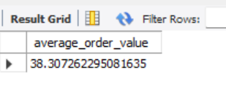

**3. Total Pizza sold:**

SELECT SUM(quantity) AS Total_Pizza_Sold FROM sales;

**OUTPUT:**

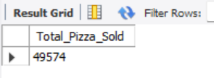

**4. Total Orders:**

SELECT COUNT(distinct order_id) AS Total_Orders FROM sales;

**OUTPUT:**

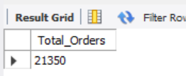

**5. Average Pizza per order:**

SELECT round(sum(quantity) / count(distinct order_id), 2) AS Avg_Pizza_per_orders FROM sales;

**OUTPUT:**

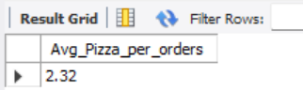

**6. Daily trend of orders:**

SELECT dayname(New_order_date) AS day_name, count(distinct order_id) AS Total_orders FROM sales

GROUP BY day_name;

**OUTPUT:**

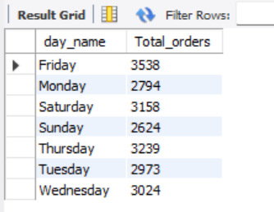

**7.Monthly trends for orders:**

SELECT monthname(New_order_date) AS Month_Name, count(distinct order_id) AS Total_orders FROM sales

group by Month_name;

**OUTPUT:**

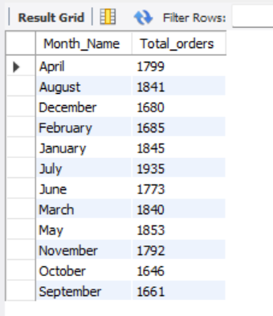

**8. % of sales by Pizza category :**

SELECT pizza_category, round(sum(total_price),2) AS Total_PRICE, round(sum(total_PRICE) * 100 / (SELECT sum(total_price) FROM sales),2) AS pct FROM SALES

group by pizza_category;

**OUTPUT:**

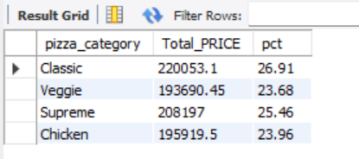

**9.% of sales by pizza size:**

SELECT pizza_size, round(sum(total_price),2) AS TOTAL_SALES, ROUND(sum(total_price) * 100 / (SELECT SUM(total_price) FROM SALES ),2) AS PCT FROM sales

GROUP BY pizza_size;

**OUTPUT:**

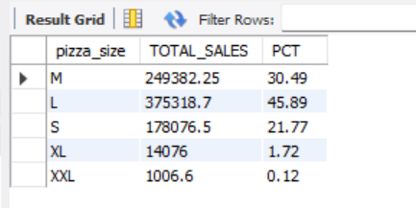

**10. Total pizza sold by Pizza category:**

SELECT pizza_category, count(quantity) AS sold_pizza FROM sales

GROUP BY pizza_category;

**OUTPUT:**

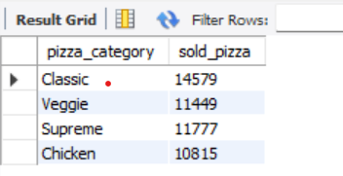

**11. Top 5 pizza by revenue:**

SELECT pizza_name, sum(total_price) AS Total_revenue FROM sales

GROUP BY pizza_name

ORDER BY total_revenue desc

limit 5;

**OUTPUT:**

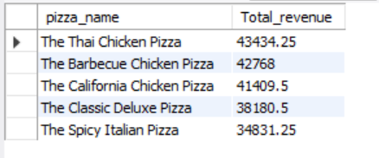

**12. Bottom 5 pizza by revenue:**

SELECT pizza_name, sum(total_price) AS Total_revenue FROM SALES

GROUP BY pizza_name

ORDER BY Total_revenue asc

limit 5;

**OUTPUT:**

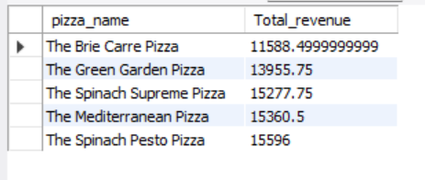

**13. Top 5 pizza by quantity :**

SELECT pizza_name, sum(quantity) AS Total_pizza_sold FROM sales

GROUP BY pizza_name

ORDER BY Total_pizza_sold desc

limit 5;

**OUTPUT:**

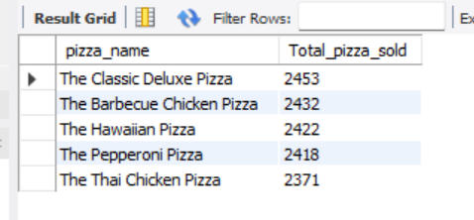

**14. Bottom 5 pizza by quantity:**

SELECT pizza_name, sum(quantity) AS Total_pizza_sold FROM sales

GROUP BY pizza_name

ORDER BY Total_pizza_sold asc

limit 5;

**OUTPUT:**

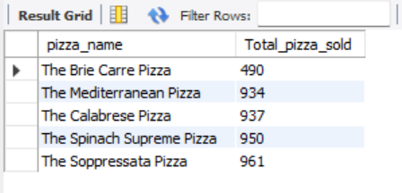

**15. Top 5 pizza by total orders :**

SELECT pizza_name, count(distinct order_id) AS Total_orders FROM SALES

GROUP BY pizza_name

ORDER BY Total_orders desc

limit 5;

**OUTPUT:**

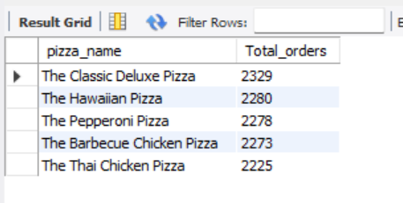

**16. Bottom 5 pizza by orders:**

SELECT pizza_name, count(distinct order_id) AS Total_orders FROM SALES

GROUP BY pizza_name

ORDER BY Total_orders asc

limit 5;

**OUTPUT:**

